

**NATIONAL ECONOMIC CONSULTATIVE FORUM**

**MONTHLY ECONOMIC BULLETIN**

**DECEMBER 2024**

# Executive Summary

This bulletin focuses on economic developments for the month ending 31 December 2024 that include, world economic developments, international commodity prices, Zimbabwe Gross Domestic Product (GDP) growth updates, merchandise trade developments, exchange rate developments, inflation developments, monetary developments and stock market developments.

**World Economic Developments**

Global economic growth in 2024 is forecasted at 3.1%, with a slight uptick to 3.2% in 2025 before declining to 3% in 2026, driven by post-election policy adjustments in the United States. The global growth outlook for 2024 was revised downward by KPMG International, largely due to geopolitical tensions and election-related uncertainties. Global inflation is projected to moderate, falling to 4.5% in 2024 and further to 3.2% by 2026, attributed to higher interest rates, slower growth, and a drop in energy prices. Inflation in major advanced economies is expected to approach central bank targets by 2025.

**International Commodity Prices**

Commodity prices exhibited mixed trends in December 2024. Crude oil, natural gas, soybeans, corn, and wheat prices rose, driven by OPEC+ production cuts and El Niño drought effects, while prices of aluminum, copper, nickel, gold, and cotton declined. YtD, natural gas, aluminum, and gold prices increased, while other commodities, including crude oil and wheat, fell.

**Zimbabwe Gross Domestic Product (GDP) Growth Updates**

Zimbabwe's GDP growth is projected at 2% in 2024, accelerating to 6% in 2025, fuelled by improved agricultural output, enhanced electricity generation due to La Niña effects, expansions in mining and information technology, and a stable macroeconomic environment.

**Merchandise Trade Developments**

Zimbabwe's merchandise trade volume reached USD 1.53 billion in October 2024, a 12.8% increase from September 2024 but 11.5% lower YoY. Exports rose by 21.4% MoM to USD 698.1 million, driven by shipments of gold and tobacco. Imports grew by 6.5% to USD 835.8 million, dominated by diesel, maize, and crude soya bean oil. The trade deficit narrowed to USD 137.7 million in October 2024, compared to USD 209.5 million in September.

**Exchange Rate Developments**

The Zimbabwean Gold (ZWG) lost value against the USD and GBP in December 2024, while strengthening against the EUR and ZAR due to improved fiscal discipline. The parallel market exchange rate remained higher than the official rate, though convergence trends were observed as the official rate moved closer to market expectations.

**Inflation Developments**

Zimbabwe's MoM inflation rate declined from 11.7% in November 2024 to 3.67% in December 2024, driven by fiscal and monetary stability. Food, non-alcoholic drinks, and housing-related costs remained key inflation drivers, while furniture and equipment prices exerted downward pressure on inflation.

**Monetary Developments**

Broad money supply increased by 16.76% in October 2024, reflecting growth in foreign currency deposits. Interest rates for local and foreign currencies were raised, promoting savings while discouraging borrowing and inflation.

**Stock Market Developments**

The Zimbabwe Stock Exchange (ZSE) experienced bearish trends in December 2024, with declines in major indices and market capitalization. Conversely, the Victoria Falls Stock Exchange (VFEX) saw significant gains, driven by increased investor confidence, tax incentives, and dollar-based trading opportunities, positioning it as a potential financial hub in Africa.

**Table of Contents**

Executive Summary i

List of Tables iv

List of Figures v

1.0 World Economic Developments 1

1.1 World Output 1

1.2 Global Inflation Developments 1

2.0 International Commodity Prices 2

3.0 Zimbabwe GDP Growth Update 3

4.0 Merchandise Trade Developments 3

5.0 Exchange Rate Developments 4

5.1 ZWG Exchange Rate Developments 4

5.2 Parallel Market Developments 5

5.3 Cross Rate Developments 5

6.0 Inflation Developments 6

7.0 Monetary Developments 7

7.1 Money Supply 7

7.2 Interest Rates 8

8.0 Stock Market Developments 8

8.1 Zimbabwe Stock Exchange (ZSE) 8

8.2 Victoria Falls Stock Exchange (VFEX) 9

9.0 Recommendations 10

References 12

# List of Tables

Table 1: Commodity Price Movements – Month Ending 31 December 2024 2

Table 2: ZWG Exchange Rate Movements-Month Ending 31 December 2024 4

Table 3: USD Exchange Rate Movements–Month Ended 31 December 2024 5

Table 4: Monthly Inflation for December 2024 7

Table 5: Interest Rates as of 13 December 2024 8

Table 6: Zimbabwe Stock Exchange Movements 9

Table 7: Victoria Falls Stock Exchange Movements 9

# List of Figures

Figure 1: Global Economic Growth Developments 1

Figure 2: Global Inflation 2

Figure 3: Merchandise Trade Developments 3

Figure 4: Parallel Market Developments - December 2024 4

Figure 5: Month-on-Month ZWG Inflation Outturn 5

Figure 6: Month-on-Month Weighted Inflation Outturn 6

Figure 7: Broad Money (M3) Supply 7

# 1.0 World Economic Developments

## **1.1 World Output**

1.1.1 Global economic growth is expected grow by 3.1%[1] in 2024 and slightly accelerate to 3.2% before post-election policies in the US dampen global growth to 3% in 2026, see Figure 1 (KPMG International, 2024).

1.1.2 S&P Global Market intelligence (2024) also highlighted that growth forecasts for 2025-26 have been reduced across most key regions and countries primarily due to the expected domestic and external implications of assumed post-election shifts in the US policy leading to a less favourable environment for trade, less accommodative financial conditions and heightened uncertainty.

Figure 1: Global Economic Growth Developments

*Source: IMF, WEO October 2024 Update and KPMG International (2024)*

## **1.2 Global Inflation Developments**

1.2.1 KPMG International (2024) projected the pace of inflation to continue cooling due to excess supply and a drop in energy prices. Global inflation is expected to fall to 4.5% in 2024, 3.5% in 2025 and 3.2% in 2026 (see Figure 2). According to Atradius (2024), global inflation is expected to continue on this soft landing path with inflation expected to approach the 2% target in the Eurozone and US by 2025.

Figure 2: Global Inflation

*Source: IFM, WEO October 2024 update and KPMG International 2024*

# 2.0 International Commodity Prices

2.1 During the month under review, commodity prices registered a mixed fortunes trend. Commodities such as crude oil, natural gas, soybeans, corn and wheat prices gained by 3.12%, 8.94%, 0.88%, 7.88% and 3.62% respectively. However, prices of aluminum, copper, nickel, gold and cotton retreated, see Table 1.

The mixed fortunes trend may be attributed to unique blend of economic policies, geopolitical pressures, and evolving supply-demand dynamics that prevailed in December 2024 (ACY Securities, 2024). OPEC+ postponed its planned production hikes, extending cuts until April 2025 leading to low supply of oil and rising prices while agricultural commodity prices firmed due to the El- Nino drought effects.

2.2 Natural gas, aluminum, copper and gold prices increased on year-to-date (YtD), while the price of corn remained stable and prices of crude oil, nickel, cotton, soyabeans and wheat declined.

2.3 On a year-on-year (YoY) basis, prices of natural gas, aluminum and gold firmed while price of other commodities fell.

Table 1: Commodity Price Movements – Month Ending 31 December 2024

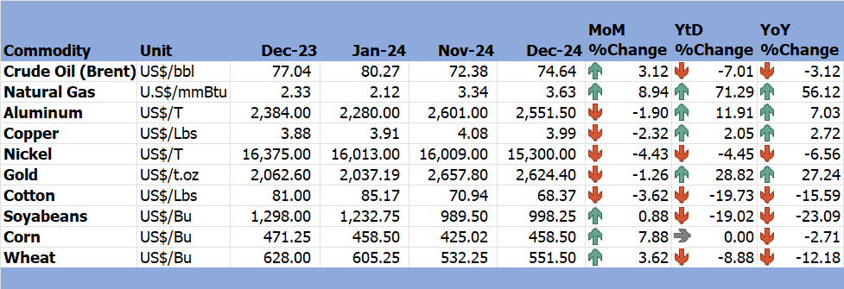

*Source: Trading Economics (2024)*

# 3.0 Zimbabwe GDP Growth Update

3.1 Zimbabwe's economic growth is projected to remain steady at 2% in 2024 and accelerate to 6% in 2025. This growth is driven by expected improvements in agriculture and electricity generation, fueled by the La-Nina phenomenon, as well as expansions in information technology, mining, and a stable macroeconomic environment.

# 4.0 Merchandise Trade Developments

4.1 Zimbabwe National Statistics Agency (ZimStat) had not published the merchandise trade data for December 2024 by the time of compiling this report, thus the analysis is based on October 2024 data.

4.2 Total merchandise trade stood to USD1533.9 million in October 2024 making a 12.8% decrease from USD1359.4 million in September 2024 due to an increase in both exports and imports. On YoY basis, merchandise trade retreated by 11.5% down from USD1733.4 million in October 2023 (RBZ October 2024 Monthly Review).

4.1 The trade deficit declined from USD209.5 million in September 2024 to USD137.7 million in October 2024. On YoY basis, it widened from USD69.7 million in October 2023 (see Figure 3).

Exports grew by 21.4% to USD698.1 million in October 2024, from USD575 million in September 2024 and 16.1% lower than USD831.9 million in October 2023, primarily driven by higher shipments of gold and tobacco, mainly to United Arab Emirates, South Africa and China.

Imports also grew by 6.5% to USD835.8 million from USD784.4 million in September 2024, dominated by diesel, maize, petrol and crude soya beans oil from South Africa, China, Bahamas and Singapore. On a YoY basis, imports fell from 901.6 million in October 2023.

Figure 3: Merchandise Trade Developments

*Source: RBZ (2024)*

# 5.0 Exchange Rate Developments

## **5.1 ZWG Exchange Rate Developments**

5.1.1 During the month under review, the ZWG lost value against the USD and GBP by 1.36% and 0.10%, respectively. The US dollar strengthened post US presidential election, driven by speculation around new economic policies. Meanwhile, the ZWG strengthened against the Euro (EUR) and South African Rand (ZAR) by 0.20% and 2.67%, respectively. This resilience was attributed to the government's fiscal discipline, as outlined in Treasury Circular No. 7 of 2024, which imposed strict expenditure controls for the last two months of 2024. On YtD and YoY basis, the ZWG lost value against all major currencies as shown in Table 2.

Table 2: ZWG Exchange Rate Movements-Month Ending 31 December 2024

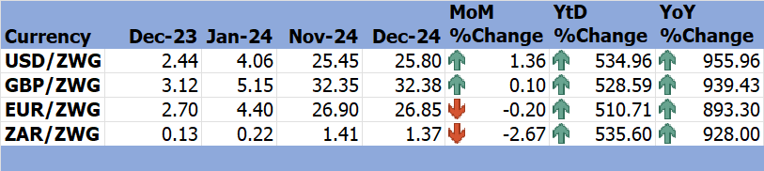

*Source: RBZ (2024)*

5.1.2 Government fiscal discipline and active citizen participation are crucial for strengthening and stabilizing the ZWG and promoting economic growth in Zimbabwe. Prudent government spending, transparency, and accountability, along with citizen involvement in decision-making processes, will help to stabilize the ZWG going forward.

## **5.2 Parallel Market Developments**

5.2.1 During the month of December 2024, the parallel market rate remained constant but higher than the official exchange rate, at USD/ZWG38 with official rate rising steadily from USD/ZWG25.57 to USD/ZWG25.80 leading to gradual decline of parallel market premium, see Figure 4. This trend encourages convergence of the two exchange rates reflecting that the official exchange rate is moving towards a true reflection of the market expectations.

Figure 4: Parallel Market Developments - December 2024

*Source: RBZ and Harare Streets (2024)*

## **5.3 Cross Rate Developments**

5.3.1 During the month under review, the USD gained by 1.27%, 1.57% and 4.15% against the GBP, EUR and ZAR respectively, driven by positive post-election expectations on the U.S economy and policy shifts, see Table 3. On both YtD and YoY basis, the USD also gained against the GBP, EUR and ZAR, except on YtD it lost against the ZAR by 0.16%.

Table 3: USD Exchange Rate Movements–Month Ended 31 December 2024

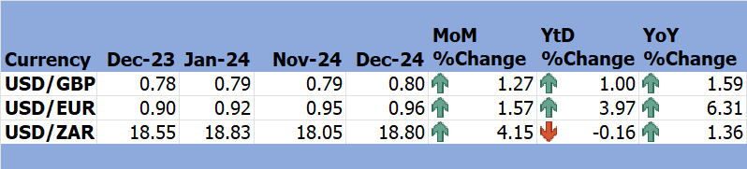

*Source: RBZ (2024)*

5.3.2 The appreciation of USD against other major currencies discourages the country’s exports to the rest of the worlds including its major exports destination such as United Arab Emarates, South Africa and China.

# 6.0 Inflation Developments

6.1 In December 2024, month-on-month ZWG inflation declined from 11.7% recorded in November 2024 to 3.67%, see Figure 5. The decline was due to stability surrounding the ZWG due to tight fiscal and monetary stance.

Figure 5: Month-on-Month ZWG Inflation Outturn

*Source: ZimStat (2024)*

6.2 MoM weighted inflation also adjusted in accordance with the ZWG inflation from 2.2% to 1.11% in December 2024. (see Figure 6).

Figure 6: Month-on-Month Weighted Inflation Outturn

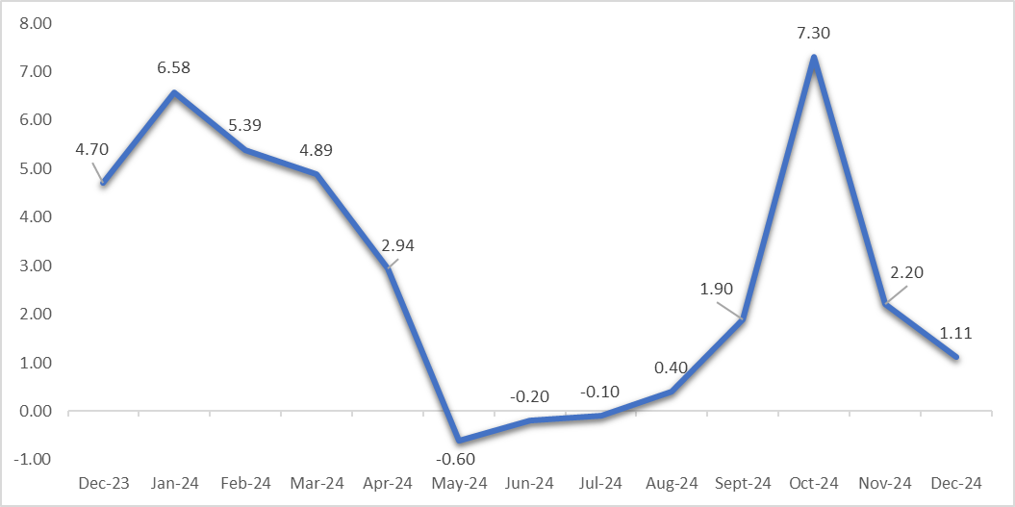

*Source: ZimStat (2024)*

6.3 Food and non-alcoholic drinks, as well as housing, water, electricity, gas, and other fuels, were the largest drivers to both weighted and ZWG inflation in December 2024 while furniture and equipment negatively influenced weighted inflation (see Table 4).

Table 4: Monthly Inflation for December 2024

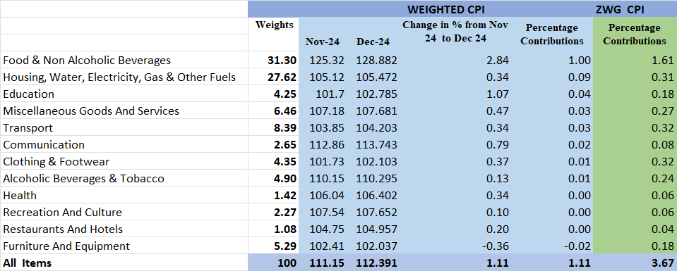

*Source: ZimStat (2024)*

# Monetary Developments

## **7.1 Money Supply**

7.1.1 By the time of compiling this report, December 2024 money supply statistics had not been published thus analysis in based on October 2024 data.

7.1.2 In October 2024, broad money stock increased by 16.76% from ZWG75.01 billion in September 2024 to USD87.58 billion in October 2024 as shown in Figure 7 (RBZ October 2024 Monthly Economic Review). The foreign currency component of broad money increased by 19.75% while local currency component grew by 0.72%. Money stock comprised of 86.48% foreign currency deposits, 13.36 local currency deposits and 0.11% local currency in circulation.

Figure 7: Broad Money (M3) Supply

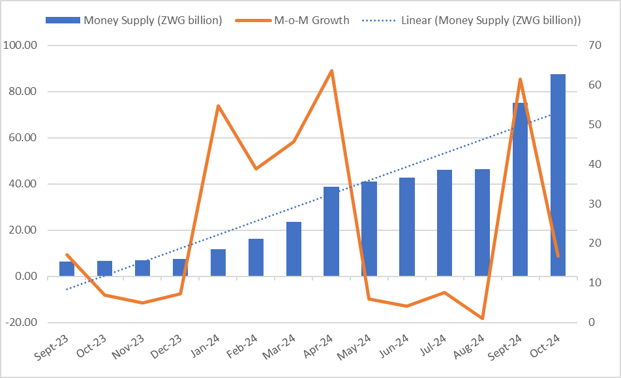

*Source: RBZ (2024)*

## **7.2 Interest Rates**

7.1.1 As of 13 December 2024, the average commercial bank deposit rate for savings on local currency was maintained at 3.75% minimum and 3.88 maximum, while on foreign currency was revised by reducing a minimum to 1.35% and increasing a maximum to 1.57. The weighted lending rate on foreign currency for individuals was raised to a minimum 13.03% and maximum of 17.42%, for corporates, it was revised to 10.657 minimum and a maximum of 16.24%. Weighted lending rates on local currency were raised upwards to a minimum rate of 41.43% and a maximum rate of 46.89% and to 39.98% minimum and 45.48% maximum for corporates (see Table 5).

Table 5: Interest Rates as of 13 December 2024

|  |  |  |  |  |  |
| --- | --- | --- | --- | --- | --- |
| **Classification** | | **Minimum (%)** | | **Maximum (%)** | |
|  | | **15/11/24** | **13/12/24** | **15/11/24** | **13/12/24** |
| Average Commercial Bank Deposit Rates | Local Currency | 3.75 | 3.75 | 3.88 | 3.88 |
| Foreign Currency | 1.38 | 1.35 | 1.50 | 1.57 |
| Commercial Banks Weighted Lending Rates (Forex) | Individuals | 12.85 | 13.03 | 17.16 | 17.42 |
| Corporates | 10.65 | 10.67 | 14.89 | 16.24 |
| Commercial Banks Weighted Lending Rates (ZWG) | Individuals | 37.97 | 41.43 | 43.47 | 46.89 |
| Corporates | 33.01 | 39.98 | 38.83 | 45.48 |

*Source: RBZ (2024)*

7.1.2 During the period under review, deposit rates and lending rates for both local currency and foreign currency were increased. Upward deposit rate review promotes savings while increasing lending rates reduces borrowing, and stifle investment and business growth.

# 8.0 Stock Market Developments

## **8.1 Zimbabwe Stock Exchange (ZSE)**

8.1.1 During the month under review, the ZSE recorded bearish sentiments. All Share Index, Top 10 Index, Value Traded, and Market Capitalization fell by 17.93%, 19.06%, 4.94% and 18.46%, respectively, see table 6. The downturn reflected a broad-based decline among major players, prominent loses losses were led by British American Tobacco Zimbabwe Limited, Delta and Hippo Valley Estates limited. Old Mutual Top Ten Exchange Traded Fund (OMTT ETF) also announced its decision to exit the market due to limited trading activity and cost-efficiency concerns.

8.1.2 On YtD and YoY basis, all selected indices gained except Value Traded which dropped by 58.57% and 84.50% respectively.

Table 6: Zimbabwe Stock Exchange Movements

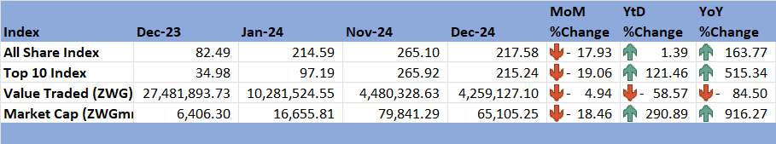

*Source: ZSE (2024)*

## **8.2 Victoria Falls Stock Exchange (VFEX)**

8.2.1 The VFEX recorded a bullish trend in December 2024, with All Share Index gaining 1.86%, Value Traded added 366.69% and Market Capitalization increased by 3.4%. African Markets (2024) stated that VFEX achieved a record-breaking turn over reflecting increased investor confidence and growing appetite for dollar-based trading opportunities in the region, due to blue-chip counters, increased listings, recent efforts to enhance liquidity, transparency and tax incentives to attract international investments. With this achievement VFEX has proved its resilience and potential to become a major financial hub in Africa.

8.2.2 On a YtD and YoY basis, all share index, value traded, and market capitalization gained as shown in Table 7.

Table 7: Victoria Falls Stock Exchange Movements

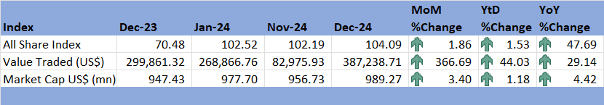

*Source: VFEX (2024)*

# 9.0 Recommendations

9.1 The following recommendations are being proposed:

**9.1.1 Policy Adjustments for Economic Growth and Stability**

**Global Economic Developments**: The country should remain vigilant about global economic trends, especially post-election policy shifts in the U.S. that may impact global trade and financial markets. Developing contingency measures, such as diversifying trade partners and enhancing regional trade, can mitigate potential external shocks.

**Domestic Economic Growth**: The government should sustain efforts to improve agricultural productivity and electricity generation, leveraging the La Niña phenomenon while expanding ICT and mining to support the 6% growth target in 2025.

**9.1.2 Strengthening Trade Performance**

There is need to enhance the competitiveness of export-oriented industries, particularly gold and tobacco, by improving value addition and exploring new markets.

There is need to review import substitution policies to reduce reliance on imports, particularly for critical commodity like maize, by fostering local production.

There is need to promote regional trade agreements to access preferential tariffs and increase Zimbabwe’s export base.

**9.1.3 Exchange Rate Stabilization**

There is need to maintain fiscal discipline and transparent monetary policies to strengthen the ZWG.

Government should encourage citizen engagement and financial literacy campaigns to foster trust in official exchange mechanisms and promote local currency usage.

**9.1.4 Inflation Management**

There is need to focus on controlling inflation drivers, especially food and energy prices, by increasing investments in renewable energy and agricultural resilience programs.

Government should strengthen supply chain mechanisms to ensure the availability of essential goods and services at stable prices.

**9.1.5 Monetary and Financial Sector Recommendations**

Interest Rates: There is need to strike a balance between encouraging savings through higher deposit rates and avoiding excessively high lending rates that may deter investment and business growth.

Broad Money Supply: There is need to monitor money supply growth to avoid inflationary pressures while ensuring adequate liquidity to support economic activities.

**9.1.6 Capital Market Development**

ZSE Performance: There is need to address bearish trends by improving investor confidence through regulatory reforms, enhanced corporate governance, and promoting new listings of high-growth sectors.

VFEX Growth: There is need to capitalize on the VFEX's success by attracting more foreign investments through enhanced tax incentives, better liquidity, and improved market transparency.

**9.1.7 Commodity Market and Price Stability**

The country should leverage opportunities in rising agricultural commodity prices due to El Niño by investing in climate-resilient farming techniques and modernizing irrigation infrastructure.

Zimbabwe should engage with international bodies like OPEC+ to advocate for stable oil prices while diversifying energy sources to reduce vulnerability to global oil price volatility.

**9.1.8 Social and Infrastructure Investment**

There is need to address social inflation drivers by expanding access to affordable housing, energy, and essential services.

The country should invest in transport and utility infrastructure to support economic activities, reduce production costs, and attract investments.

# References

ACY Securities. (2024, December). *Commodity Outlook December 2024*. Retrieved from ACY Securities: https://acy.com/en/market-news/market-analysis/commodity-market-outlook-december-2024-103544/

African Markets. (2024:, December). *African Markets*. Retrieved from Stock Markets: https://www.african-markets.com/en/stock-markets/zse/zimbabwe-vfex-records-historic-turnover-boosting-market-confidence

IMF. (2024). *World Economic Outlook, October 2024; Global prospects and Policies: Chapter 1.* International Monetary Fund.

RBZ. (2024). *Exchange Rates*. Retrieved from Reserve Bank of Zimbabwe: https://www.rbz.co.zw/index.php/research/markets/exchange-rates

Reserve Bank of Zimbabwe. (2024). *Monthly Economic Review: October 2024.* RBZ.

Reserve Bank of Zimbabwe. (2024). *Weekely Economic Highlights, 13 December 2024, Vol 26 No 50.* Reserve Bank of Zimbabwe.

Trading Economics. (2024). *Commodities*. Retrieved from Trading Economics: https://tradingeconomics.com/commodity/crude-oil

VFEX. (2024). *Main Dashboard*. Retrieved from Victoria Falls Stock Exchange: https://www.vfex.exchange/

ZimStat. (2024). *Inflation Rates*. Retrieved from Zimbabwe Statistics Agency: https://www.zimstat.co.zw/

ZSE. (2024). *Main Dashboard*. Retrieved from Zimbabwe Stock Exchange: https://www.zse.co.zw/

**NECF Secretariat, 2024**

1. The global growth projections by KPMG International Global Growth Outlook for 2024 differ slightly by 0.1% from the IMF WEO Outlook projections, see Figure 1.